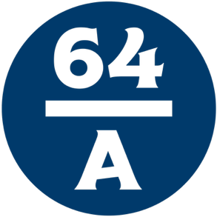

Cazenovia’s 3rd Annual Dining Week
February 15 – 28, 2026
____________________

First Course

French Onion Soup
New England Clam Chowder
Caesar Side Salad

Second Course

The Burger
A savory Angus Beef patty flame grilled to order and served on a seeded Brioche Bun with lettuce, tomato, onion, pickle and our secret sauce

The State Fair Steak Sandwich
Shaved steak topped with sauteed peppers and onions, finished with melted mozzarella cheese on a hoagie roll

The Chicken Sandwich
A tender Chicken cutlet tossed in seasoned breading and fried until golden brown, served on a seeded Brioche Bun and topped with lettuce, tomato, onion, pickle, Chipotle Ranch and Hot Maple sauce

Third Course

NY Cheesecake

Peanut Butter Pie

